Annex B: eTeens Opt-out Form
(To be completed by parents of Year 3 and 5 students)
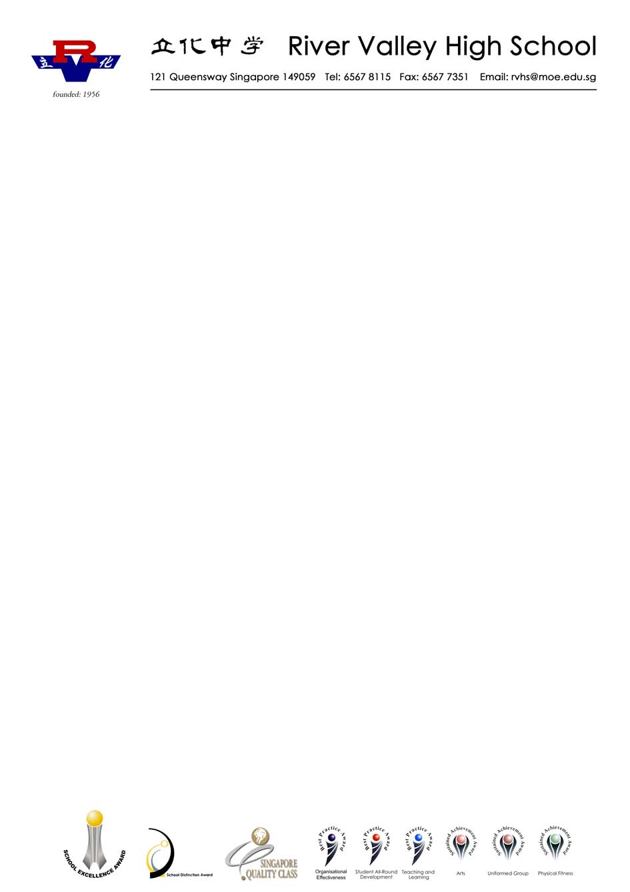

Note: Information on the eTeens programme can be found in Annex C.

6 Boon Lay Avenue
Singapore 649961
Republic of Singapore
Tel: (65) 65678115
Fax: (65) 65677351
Email: rvhs@moe.edu.sg
RIVER VALLEY HIGH SCHOOL

Date: ______________

Parent’s Name: ____________________ Parent of (Child’s name): ___________________

Mrs Teo Khin Hiang
River Valley High School

Dear Mrs Teo

I, (name) _____________________________, (NRIC) ________________, do not wish my son/daughter/ward*, (name) ___________________________________ of class _________, to attend the eTeens STI/HIV Prevention Programme conducted by the Health Promotion Board.

My reason(s) for opting out:
❑ My child is too young.
❑ I would like to personally educate my child.
❑ I am not comfortable with the topics/content to be covered.
❑ Religious reasons
❑ I have previously taught my child the topics/content to be covered.
❑ I do not think it is necessary for my child to attend.
❑ Others (please state): _____________________________________

Child’s Religion: ____________________ Race: _____________________

____________________________ _____________________
Signature of Parent/Guardian Date
Annex C: Information on the eTeens Programme

Dear Sir/ Madam

eTeens
STI (Sexually Transmitted Infections) /
HIV (Human Immunodeficiency Virus)
Prevention Programme in Schools

The Health Promotion Board (HPB) has been conducting an STI/HIV Prevention Programme in schools since 1993. The programme aims to raise awareness on STI/HIV, inform students about ways to prevent infection and discourage risky sexual behaviours.

2. In view of the increasing number of STIs reported among youth aged 10-19 years, HPB, in collaboration with the Ministry of Health (MOH) and the Ministry of Education (MOE), developed an STI/HIV programme titled eTeens for students in secondary schools and JC/CIs.

3. eTeens comprises an assembly talk and classroom-based learning. It covers information on the transmission modes of STI, the signs, symptoms and consequences of contracting STI/HIV, effective methods of preventing infection including abstinence from pre-marital sex, being faithful to one partner in the context of marriage as well as condom use. It also teaches life-skills such as decision-making, assertiveness and negotiation skills. eTeens is conducted in schools by trained personnel from HPB and teachers. A factsheet on the programme, which is available on the MOE website, is enclosed.

4. If you do not wish your son/daughter/ward to attend this programme, please complete the form on Annex B and return it to the school. For any clarification regarding this programme, please email us at hpb_yhp@hpb.gov.sg.

Thank you.
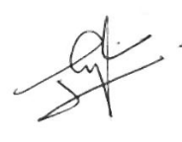
Yours sincerely

Mrs Cheong-Lim Lee Yee
Deputy Director
Educational Institution Outreach Department
Youth Health Division
Health Promotion Board

Reported cases of STIs among youth aged 10-19 years increased from 238 cases in 2002 to a peak of 820 cases in 2007.
Previously known as Breaking Down Barriers (BDB).
www.moe.edu.sg/education/programmes/social-emotional-learning/sexuality-education

